**Year 8 Science (M)**

**2021**

**Topic Test:**

**Periodic Table, Atomic Structure & Kinetic Theory**

**Name: _________________________** **Marks: 46**

**Mrs Prasad**



**Materials Required:**

* **Blue/black ballpoint pen**
* **Pencil**
* **Ruler**
* **Eraser**
* **Calculator**

|  |  |  |
| --- | --- | --- |
| **Section 1**  **(8)** | **Section 2**  **(38)** | **Total**  **(46)** |
|  |  |  |

**Section 1: Multiple Choice**  **[8 Marks]**

**Circle the letter of the most correct answer for each of the statements or questions below.**

1. The charge of an electron is
2. Positive
3. Negative
4. No charge
5. None of the above
6. To be called “matter”, a substance must have
7. Shape and volume
8. A mass over 1kg
9. Mass and volume
10. Feelings
11. Which of the following statements about the particles in an atom is correct?

1. Protons are not found in the nucleus
2. Protons and neutrons are found in the nucleus
3. Neutrons are positively charged
4. Atoms are around the size of your finger
5. The Kinetic Theory of Matter states that all matter (everything on earth) is made up of
6. Electrons moving everywhere
7. Just solids
8. Gases and liquids
9. Small moving particles called atoms
10. The atomic number of an element is equal to its number of
11. Atoms
12. Protons
13. Neutrons
14. How can you tell when something is a solid?
15. It will pour
16. It takes the shape of its container
17. It cannot be seen easily
18. It will hold its shape
19. When you add energy (for example: heat) to a substance which of the following occurs?
20. Particles become more attracted
21. Particles get larger
22. Particles move faster
23. Particles get smaller
24. A cylinder is filled with two liquids **X** and **Y**. Two different solid objects **W** and **Z** are placed in the liquids and are found to position themselves as shown in the diagram below:



The order of the four substances, from most dense to least dense is:

1. Z, X, Y, W
2. Z, Y, X, W
3. Z, W, Y, X
4. W, X, Y, Z

**End of Section 1**

**Section 2: Short Answers**  **[38 Marks]**

**Answer ALL questions in the spaces provided below. Use a blue or black pen unless you have been asked to draw a diagram.**

**Question 11** **[10 Marks]**

The symbols or names of several chemical elements are presented in the table below. Complete the table by filling in the correct name or symbol of each element in the appropriate space.

|  |  |
| --- | --- |
| **Symbol** | **Element Name** |
| H |  |
| He |  |
| Li |  |
| Be |  |
| C |  |
|  | Oxygen |
|  | Neon |
|  | Boron |
|  | Sodium |
|  | Magnesium |

**Question 12**   **[9 Marks]**

a. Complete the table below by drawing a simple illustration to show the what the particles that make up the substance looks like. You do not need to ‘fill’ the whole container. (3 marks)

|  |  |  |
| --- | --- | --- |
| **Solid** | ngle,Area,Cylinder PNG Clipart - Royalty Free SVG / PNG**Liquid** | **Gas** |
| ngle,Area,Cylinder PNG Clipart - Royalty Free SVG / PNG |  | ngle,Area,Cylinder PNG Clipart - Royalty Free SVG / PNG |

b. Briefly describe why you drew the particles above in this way. How do the particles in each container move? (6 marks)

Solid: I drew it like this because: _________________________________________

__________________________________________________________________

The particles in a solid move by: _________________________________________

___________________________________________________________________

Liquid: I drew it like this because: ________________________________________

__________________________________________________________________

The particles in a solid move by: _________________________________________

___________________________________________________________________

Gas: I drew it like this because: _________________________________________

__________________________________________________________________

The particles in a solid move by: _________________________________________

___________________________________________________________________

**Question 13**  **[10 Marks]**

Select the objects from the in the box below that best matches the states of matter in the table. Each term may be used only once. Cross the objects off once written in the table.

|  |
| --- |
| **ice ; carbon dioxide ; petrol ; iron ; cooking oil ; helium; diamonds ; steam ; t-shirt ; sweat** |

|  |  |  |
| --- | --- | --- |
| Solid | Liquid | Gas |
|  |  |  |

**Question 14 [4 Marks]**

Refer to the diagram of a Lithium atom, fill-in the 5 labels. The first one has already been done for you.

Electron Shell

Question 19 [5 Marks]

This illustration shows the changes of state between the three types of matter. Place each word from the box below in the correct place on the diagram.

|  |
| --- |
| liquid ; freezing ; cooling ; melting ; gas |

Sublimation

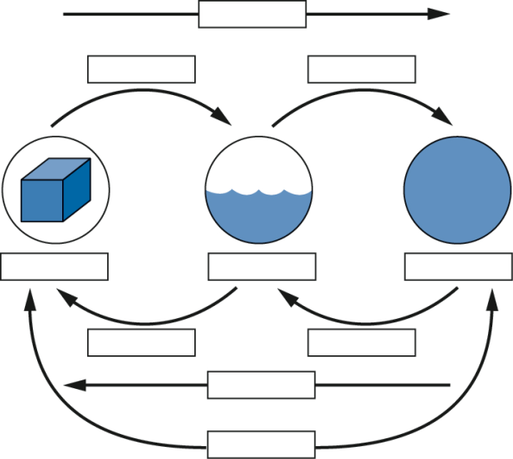

Solid

Evaporating

Condensing

Heating

**End of Test**